# Changes 24 Oct. 14

Powerball Flow

<http://blacksweets.co.za/PayU/Phase-4-HTML/powerball/2.html>

update mobile icon as per powerball

<http://blacksweets.co.za/PayU/Phase-4-HTML/powerball/3.html>

success icon skewed

<http://blacksweets.co.za/PayU/Phase-4-HTML/powerball/5.html>

update icons

<http://blacksweets.co.za/PayU/Phase-4-HTML/powerball/6.html>

remove balls 46-49

<http://blacksweets.co.za/PayU/Phase-4-HTML/powerball/9.html>

headers hidden

<http://blacksweets.co.za/PayU/Phase-4-HTML/powerball/14.html>

icon skewed

<http://blacksweets.co.za/PayU/Phase-4-HTML/powerball/17.html>

icon skewed

Electricity Flow

split tables - http://blacksweets.co.za/PayU/Phase-4-HTML/electricity/9.html

Lotto Flow

<http://blacksweets.co.za/PayU/Phase-4-HTML/lotto/10.html>

merge the :”Your No’s table” into the main table:

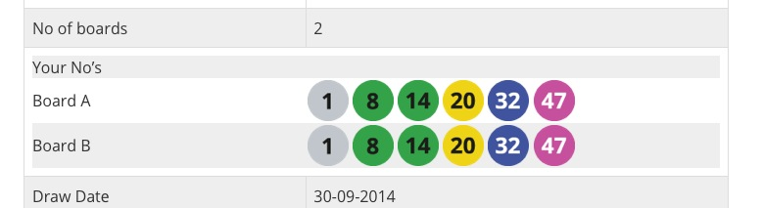

<http://blacksweets.co.za/PayU/Phase-4-HTML/lotto/11.html>

Incorrect success icon



Merge the 2 tables:

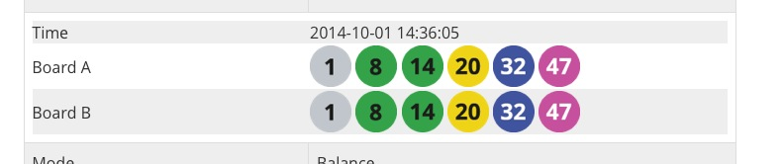

<http://blacksweets.co.za/PayU/Phase-4-HTML/lotto/13.html>

merge the :”Your No’s table” into the main table:



<http://blacksweets.co.za/PayU/Phase-4-HTML/lotto/14.html>

should have the following icon as well

